PROJECT REPORT
ON
SCHOOL OF TECHNOLOGY AND APPLIED SCIENCES
Submitted for the partial fulfilment of the requirements for the award of the Degree of
Bachelor of Computer Applications
At
SCHOOL OF TECHNOLOGY AND APPLIED SCIENCES
KOTTAYAM, KERALA


By

SANDRAMOL K.S

Reg. No: 220021089667
Department of Computer Science
SCHOOL OF TECHNOLOGY AND APPLIED SCIENCES
CENTRE FOR PROFESSIONAL AND ADVANCED STUDIES
KOTTAYAM, KERALA

2022-2025

SCHOOL OF TECHNOLOGY AND APPLIED SCIENCES
CENTRE FOR PROFESSIONAL AND ADVANCED STUDIES
KOTTAYAM, KERALA


CERTIFICATE

This is to certify that the project entitled “ONLINE ART GALLERY USING BLOCKCHAIN PAYMENT" is the Bonafide record of work done by SANDRAMOL K.S, Reg No: 220021089667, and submitted to the university for the partial fulfilment of the award of the Bachelors’ degree in Computer Application during the academic year 2022-2025.
Place: KOTTAYAM
Date:

Mrs. MANJU G R Mrs.ARYA DEVI Mrs. AJEENA KA
Head of the Department Project Coordinator Project Guide

Examiner 1: Examiner 2:

SCHOOL OF TECHNOLOGY AND APPLIED SCIENCES
CENTRE FOR PROFESSIONAL AND ADVANCED STUDIES
KOTTAYAM, KERALA



DECLARATION

I SANDRAMOL K.S hereby declare that this project work entitled “ONLINE ART GALLERY USING BLOCKCHAIN PAYMENT” is the result of the original work done by me during the period of study 2022-2025 at SCHOOL OF TECHNOLOGY AND APPLIED SCIENCES PULLARIKKUNNU, KOTTAYAM. This project report is submitted for the partial fulfilment of requirements for the award of Bachelor of Computer Application of Mahatma Gandhi University.

Place: KOTTAYAM SANDRAMOL K.S
Date:

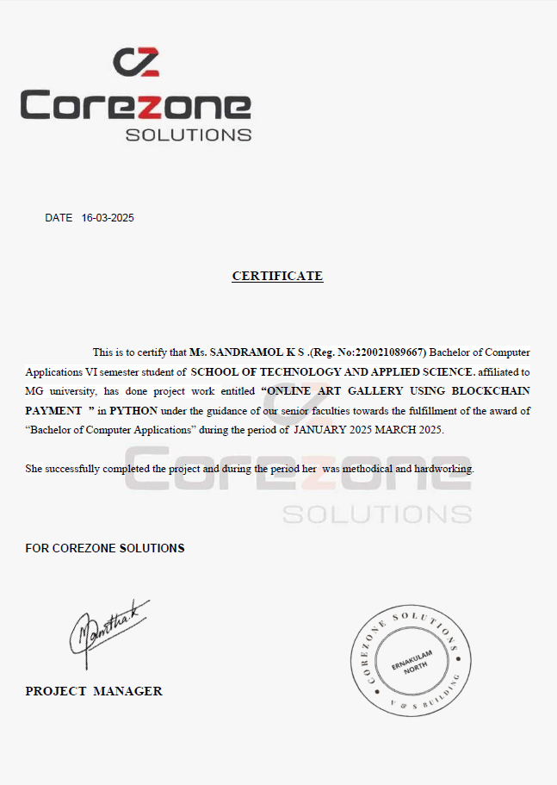

ACKNOWLEDGEMENT

Gratitude and gratefulness are a sublime feeling of heart which come to acknowledge the heartfelt gratitude. Words prove to be small, and sentences become feeble to bear the burden to express their cooperation which makes my task much easier. However, I have made an effort to express my overwhelming sense of gratitude of those who have made this task possible.
Primarily I would thank God almighty for being able to complete this project with success.
Then I would thank my principal (In-charge) Mrs. JISHA MARY GEORGE for making my project success.
I am also thankful to (In-charge) Mrs. MANJU G R, Head of Department of Computer Science for rendering valuable help and for providing means and all facilities to carry out the project.
I am extremely thankful and pay my gratitude to Mrs. ARYA DEVI for valuable guidance and support on completion of this project in its presently.
It gives pleasure to record my deep sense of gratitude, indebted to my guide Mrs. AJEENA K A for her comfort encouragement, able supervision, constructive suggestion and everlasting affection throughout the period of my work.
It is my privilege and pleasure to express my heartfelt gratitude to all the staff members of order for lending a helping hand when needed.
Then I would like to thank my parents who have helped me with their valuable suggestions and guidance, it has been helpful in various phases of the completion of the project.
I also take this opportunity to thank my classmates for their generous cooperation and support.
I am also thankful to the non-teaching staff for their helping hands.

ABSTRACT
The rise of digital marketplaces has transformed the art industry, enabling artists to showcase their work globally. However, traditional online payment systems often involve high fees, slow processing times, and security concerns. This paper explores the implementation of blockchain technology exclusively for payments in an online art gallery, ensuring fast, transparent, and secure transactions. Blockchain's decentralized nature enhances security, preventing fraud and chargeback issues commonly associated with conventional payment methods. Additionally, the system can support multi-currency transactions, providing flexibility for a global audience. This approach fosters a more efficient and accessible art marketplace while maintaining trust and financial autonomy for both artists and collectors. The paper discusses the benefits, challenges, and potential future implications of integrating blockchain-based payments in the online art industry.

TABLE OF CONTENTS
CHAPTER PAGE NO
1. INTRODUCTION
1.1 Introduction………………………………………………………………………………2
1.2 Problem Statement……………………………………………………………………….4
1.3 Scope and Relevance of the Project……………………………………………...…........4
1.4 Objectives………………………………………………………………………………...5
2. SYSTEM ANALYSIS
2.1 Introduction………………………………………………………………………………7
2.2 Existing System…………………………………………………………………………..8
2.2.1 Limitations of the System………………………………………………………….8
2.3 Proposed System………………………………………………………………………….8
2.3.1 Advantages of the proposed system………………………………………..……….8
2.4 Feasibility Study………………………………………………………………………...11
2.4.1 Technical Feasibility……………………………………………………….....11
2.4.2 Operational Feasibility………………………………………………………..11
2.4.3 Economic Feasibility………………………………………………………..12

3. SYSTEM DESIGN
3.1 Introduction……………………………………………………………………………..14
3.2 Database Design…………………………………………………………………………14
3.2.1 Design Consideration……………………………………………………………….17
3.2.2 Tables……………………………………………………………………………..18
3.3 Process use case diagram……………………………………………………………….23
3.4 Input Design………… ………………………………………………………………….29
3.5 Output Design…………………………………………………………………………..30
4. SYSTEM ENVIRONMENT
4.1 Introduction……………………………………………………………………………..32
4.2 Software Requirements Specification……………… …………………………………..32
4.3 Development Tools…………………………………………………………………..33
5. SYSTEM IMPLEMENTATION
5.1 Introduction………………………………………………………………………….40
5.2 Coding ……………………………………………………………………………….41
5.2.1 Code Validation And Optimization…………………………………………………41
6. SYSTEM TESTING
6.1 Introduction……………………………………………………………………..43
6.2 Black Box Testing………………………………………………………………………43
6.3 White Box Testing………………………………………………………………………44
6.4 Unit Testing………………………………………………………………………..44
6.5 Integration Testing………………………………………………………………………44
6.6 User Acceptance Testing……………………………………………………………..44
7. SYSTEM MAINTENANCE
7.1 Introduction………………………………………………………………………………….46
7.2 Maintenance………………………………………………………………………………47
8. FUTURE ENHANCEMENT AND SCOPE OF FURTHER DEVELOPMENT
8.1 Introduction…………………………………………………………………………….49
8.2 Merits Of The System……………………………………………………………………49
8.3 Limitation Of The System…………………………………………………………..50
8.4 Future Enhancement Of The System………………………………………………………..51
9.CONCLUSION 49
10. BIBLIOGRAPHY 51
11.APPENDIX 52

